Focus Keyword :mens wedding bands
Secondary keyword:
mens gold wedding bands​
gold wedding band​
Diamond wedding Bands
Sapphire bands
Meta Description:
Find the perfect men's wedding band at Crown Jewelers. From classic gold to modern diamonds & sapphires, we offer trendy styles you'll love wearing daily.

Trendy Men's Wedding Bands You'll Love to Wear!
Your wedding band represents both a symbol and a functional element. Your band signifies your devotion and presents your unique individual fashion. A man must make the right choice when selecting his wedding band. You need to choose a wedding band that matches both your individual style and lifestyle since you will wear it daily.
Men’s wedding bands have evolved. Time has changed and left behind basic traditional wedding bands. Contemporary wedding bands for men exist in many different design options, including different types of metal and coatings. You can now choose wedding bands that blend traditional or contemporary designs depending on your personal preferences.
This blog provides essential guidance to help you choose the right wedding band for men. We will explain popular present-day styles plus future trends and show you how to select the right piece of jewelry. Through this guide, you will reach the point of making a successful wedding band purchase.

Understanding the Basics of Men's Wedding Bands

A. What are mens wedding bands?

A men’s wedding band is a ring exchanged during the wedding ceremony. The band represents an everlasting dedication between two partners. A wedding band differs from an engagement ring through its plain and unadorned appearance. These bands reflect deep feelings regardless of their basic design. The rounded wedding band design shows the endless connection between partners as it has no beginning or ending part. Your wedding ring helps you remember the love you promised, and the wedding promises you made.
B. Factors to consider when choosing a wedding band?

Style:
You need to select a wedding band that matches your individual style preferences. At Crown Jewelers, we offer design choices for everyone who likes basic or contemporary styles. Your selection of a wedding band needs to fit your lifestyle, how you dress, and how you earn money, plus your personal style.

Material:
The band material decides how well it stands up to use while looking and feeling comfortable. Most customers like to pick metals such as gold, platinum, titanium, and tungsten when shopping for wedding bands. You can select the wedding band material based on how you live your daily life.

Lifestyle:
Consider your daily activities before making any choice. A person who leads an active lifestyle should pick titanium as their wedding band material because it resists damage. If you are working in a professional environment, you should choose polished gold or platinum bands.

Trendy Styles of Men's Wedding Bands

A. Classic Mens Gold Wedding Band​
Our mens gold wedding bands​ have stood the test of time. These bands work with various styles and maintain their popularity forever.

Versatility and Timeless Appeal:
Gold bands serve both business professional and everyday wear settings. They remain popular for an indefinite amount of time and keep their elegant look. You can find the perfect wedding band in our collection between the three gold variations of yellow, white, and rose. Striking yellow gold stands for warm tradition, but white gold looks modern and elegant. The pinkish shade of rose gold brings elegant and romantic flair to any design.

Popular Finishes: Matte, Polished, and Brushed
Matte: Offers a modern, understated look. Men who want a diminished shine will find matte finishes perfect for their tastes.
Polished: Provides a shiny, classic finish. People who favor classic style should pick polished bands because they radiate sophistication at once.
Brushed: Combines matte and polished elements for a unique texture. Brushed patterns on the band will bring out both texture and personality.
Crown Jewelers presents multiple styles of wedding bands made from gold for male customers. Our selection includes every gold type, including yellow and white. Our collection includes wedding bands with all types of decoration styles to match anyone's preferences.

B. Modern Diamond Wedding Bands
Diamonds aren’t just for women only. Men are choosing diamond wedding bands because of their stylish design and brilliant stones.

Incorporating Diamonds into Traditional Designs
Regular bands get an elegant enhancement through diamond additions. Men who prefer shine but do not prefer over-the-top styles should prefer perfect diamond-featured bands.

Various Settings and Styles for Diamond Bands
Channel Setting: The band's surface receives its beauty due to embedded diamonds on the settings. This setting ensures the diamonds survive daily activities because it surrounds and shields them completely.
Pave Setting: Many small diamonds decorate the surface to reflect brilliant light. Men who desire a touch of shine will enjoy Pave settings for their wedding bands.
Solitaire Setting: A solitary diamond features as the main accent on the band. The chosen design provides a stylish and simple look that men like best.
Benefits of Choosing Diamond-Accented Men's Wedding Bands
A diamond band offers toughness combined with multiple design choices for everyday use. Men looking for wedding bands that capture attention will find ideal choices in diamond bands. People see diamonds as signs of endurance and strength, so they work perfectly with wedding bands.

C. Sapphire Bands
Men now opt for beautiful colored gemstones instead of traditional metal bands at their weddings. People are drawn to wedding bands with sapphire accents as their fashionable option.

The Rise in Popularity of Colored Gemstones
Sapphire presents a great choice beyond conventional wedding rings. Their intense blue color brings lively style to any design. The wisdom and loyalty that sapphires represent make them perfect for wedding band selection.

Unique Designs Featuring Sapphire Stones
A sapphire band can hold either one stone or multiple stones without changes. To make the sapphire bands stand out, they commonly contain white gold or platinum accents at the edges. Several designs weave sapphires into beautiful paisley and other complex designs to create a one-of-a-kind wedding band.

Reasons to Choose Sapphire Bands Over Traditional Options
Sapphire bands offer both beauty and toughness through memorable designs. They stand out as an excellent option for men looking for a wedding ring that matches their personal style. Sapphire bands stand out as excellent daily wear jewelry because this stone resists scratching effectively.

Emerging Patterns in Men's Wedding Bands

A. Mixed Metal Designs
Men now prefer mixing two different metal types when choosing their wedding bands. The bands feature different metal mixes to achieve one-of-a-kind designs.

Combining Gold with Platinum or Titanium:
Platinum and gold mix to make an elegant polished contrast. Defects from daily life cannot harm titanium while providing today's look. Men choose mixed metal bands because they create a special wedding ring, both attractive and personal.

Trend Toward Personalization and Uniqueness
Customization has no limits with mixed metal bands. Select metal types that match your personal style and personality. People seeking a unique style can experiment freely with mixed metal wedding bands since they have limitless design choices.

B. Nature-Inspired Designs
Nature-inspired designs are perfect for men who love the outdoors.

Organic Shapes and Textures
The bands show the look of real wood and stone surface texture. These rings offer men who like earthy rustic styles an excellent selection. Using natural elements like leaves, branches, and waves helps design unique wedding rings with deep personal significance.

Eco-Friendly Options: Sustainable Materials
If you are seeking eco-friendly options by using recycled metals combined with ethically supplied gemstones, then you should pick this design. They’re perfect for eco-conscious grooms. If you care about the planet, eco-friendly bands become your stylish choice in wedding jewelry.

Tips for Selecting the Perfect Men's Wedding Band

A. Consider Lifestyle and Daily Wear Requirements
Choose your wedding band based on your regular daily functions. People who use their hands for work should choose bands made from tungsten or titanium because these materials hold up well against everyday wear. A professional setting requires a wedding band made of polished gold or platinum materials. Pick the band material based on your everyday usage because you'll be wearing it regularly.

B. Understanding Sizing and Fit
The right band size fits nicely and feels pleasant on your finger. Go to a professional jeweler to determine your correct finger size correctly. Your fingers may grow or shrink depending on body temperature and weight adjustments. The ring band should rest comfortably on your finger without feeling constrictive.

C. Importance of Quality Craftsmanship
The expert skills of our maker keep your band working well through many years. You should visit Crown Jewelers because it creates high-quality wedding bands. A band built with good craftsmanship enhances appearance while ensuring durability through time. Look for products with perfect details in their settings and finish work when you want top-quality products.

Conclusion:

Men have many wedding band choices between traditional gold rings and contemporary diamond bands with sapphires. Wedding bands come in different styles that fit either traditional or modern taste preferences.

Testing different wedding band styles brings no risk to you. Select a wedding band that fits your style because it should match your unique character. Look at many band types and materials to select an item that matches your personality.

Shop here to discover your ideal wedding band option. Visit Crown Jewelers today. View the various styles of men's wedding bands that we have carefully chosen, including gold, diamond, and sapphire selections. We like to lead you to wedding bands for a permanent partner.
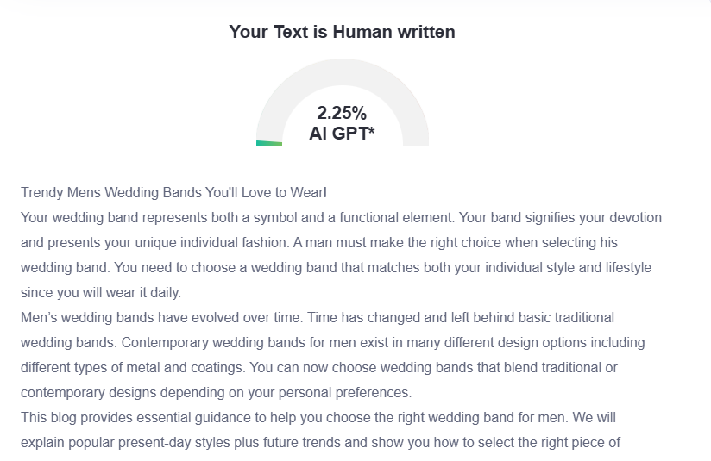

GMB
Find out the perfect wedding band that matches your personal style at Crown Jewelers! A wedding band both displays your style integrity and symbolizes the strength of your commitment to matrimonial vows. All customers will find their ideal wedding band at Crown Jewelers among our selection of yellow gold, white gold or rose gold shapes. Diamond-accented bands at our store present channel, pave, or solitaire designs to provide an elegant touch. Looking for a pop of color? The durable sapphire bands mark both wise personality traits and loyal character attributes. Our diverse selection includes wedding bands that merge multiple metals like gold, platinum or titanium as well as earth-inspired bands showing natural patterns for the active man. Review your lifestyle and correct sizing along with quality craftsmanship when choosing your band because our experts deliver exceptional results in these domains. Our Crown Jewelers team will assist you in discovering wedding bands that harmonize your personal fashion choices with your regular routines. You can experience our remarkable selection of men's wedding bands during a visit to Crown Jewelers. Professional staff from Crown Jewelers will support you through your ring selection process to locate the perfect symbol of commitment along with personal style. Remember, you'll wear this band every day, make sure it's one you'll love!

.

